Bitbucket account: the notes

Email: [tuxfux.hlp@gmail.com](mailto:tuxfux.hlp@gmail.com)

Class 1:

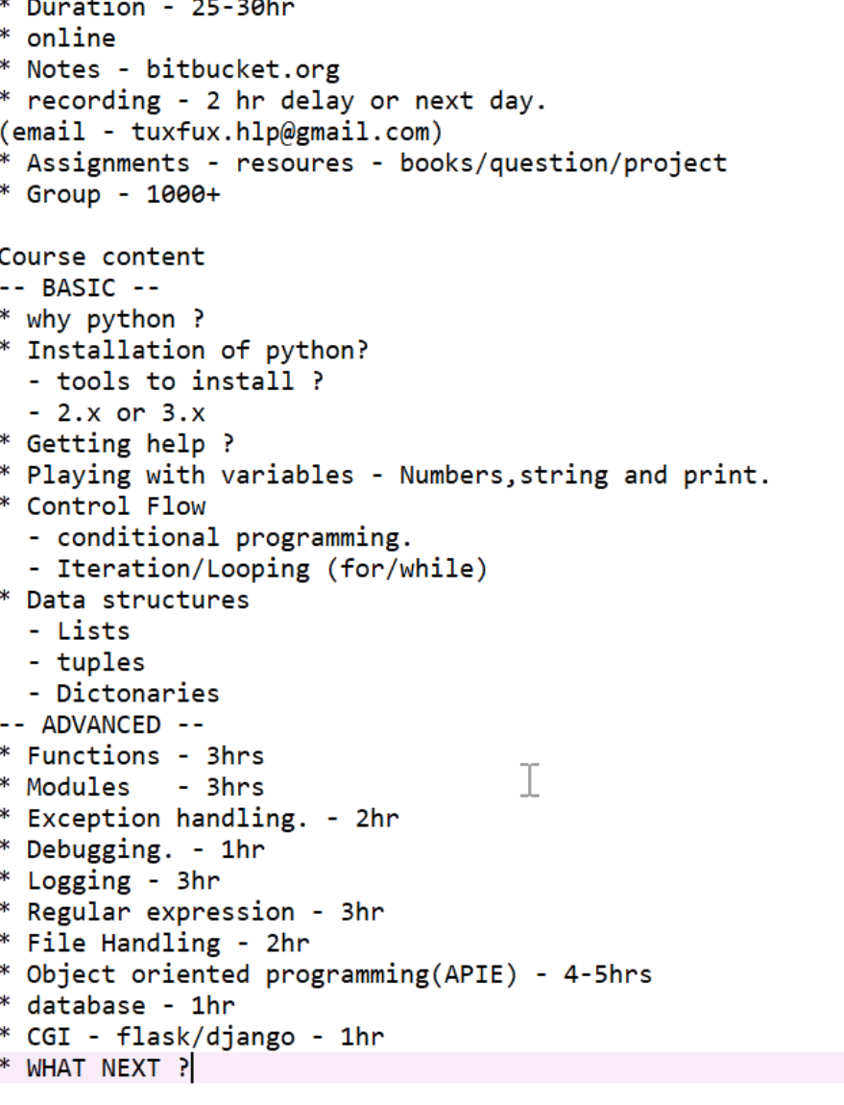

**Class: Monday 2nd week**

Print(“your name is {}. Roll number is {}”). format(name ,roll-no)

Type(name): returns the variable type

Conditional programming: it can be used inside conditional statemeng.

Python is an indentation programming. (4 spaces)

If 5<3:

Pass : passes the statement

If:

Else:

Elif:

Else:

**Class: Tuesday**

Import sys

Sys.exit exitd us from the program .. can be used with condition ….

**Class Wednesday:**

In operator

 for i in list1:

        c+=1

**class Thursday:**

list to string.

.join(list)

String to list

.list ==lists into each character

.split=creates a list from string

.insert(1,apple): inserting in desired list position

.extend= adding the list

**Class Friday:**

Memory in python

Copy module … import copy

Copy.deepcopy(5) assings the same object into different memory location.

Id(1)==shows the memory location.

**Class Monday: 10/28/2019**

.index, len

List comprehension:

Creating a new list or a modified list from an existing list.

.extend adds to list

**Class Wednesday:**

In—key word

. keys provide the keys associates with dictionaries

. values

.update: adds to dict

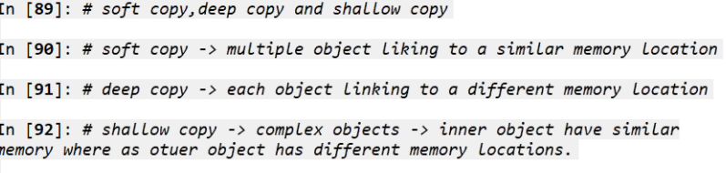

Class:

Main,

Sys path… importing path